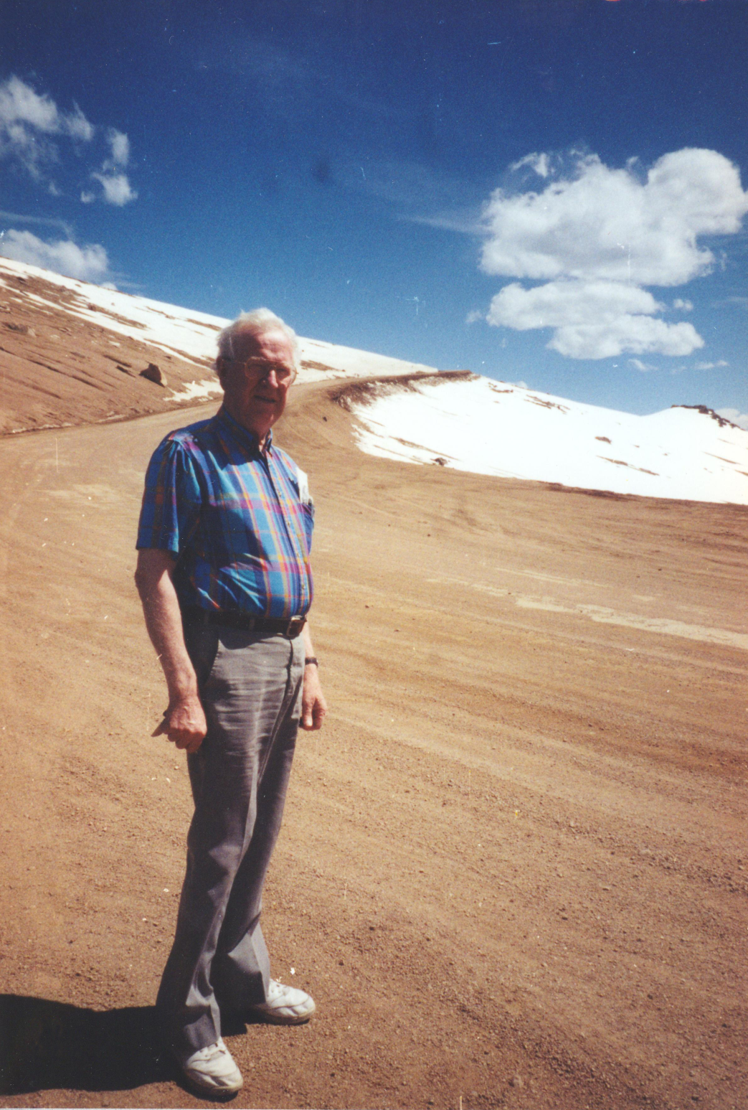

At the End of the Road
In Loving Memory of Peter Archie Kliewer

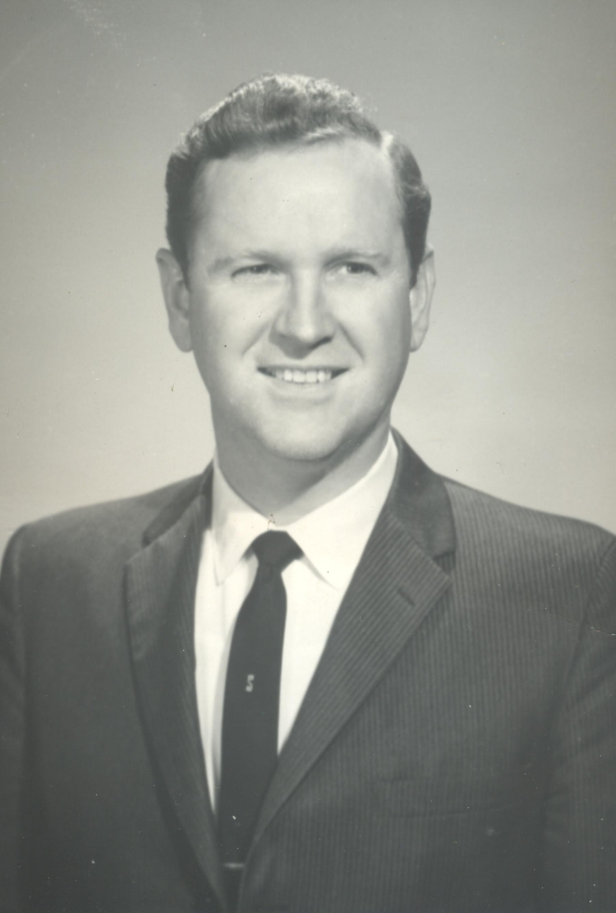

May 12, 1922 – January 4, 2013

His Life

Peter Archie Kliewer was born in Fairview, OK on May 12, 1922 to a Dutch Mennonite Brethren family. He was the youngest of 12. Only 8 survived childhood. His father, Peter Abraham Kliewer, a Dutch immigrant, traveled from a village near the Don River, South Russia to America when he was 7 years old. He and his brothers worked as shepherds to repay their sponsors for the travel expense. Peter met his future wife, Anna Becker, in the fifth grade at a school near Lehigh, KS. The family moved during the Oklahoma run to Fairview, OK where the Süd Hoffnungsfeld Church was formed. Archie’s father served as the choir director for 30 years, met again and married Anna Becker, a lovely alto singer in his choir. Archie was five (July 1927) when the family moved to Ulysses, Kansas. He attended the Spring Valley School (named by his father). Later, he and his brothers and a school friend formed the Spring Valley Quartet. Archie was the choir director at the Spring Valley Church. He farmed with his brothers and loved to sing and play the French harp (his mother taught him to play before he could walk). He continued to study music on his own by reading books about singing. As a teenager, during a youth meeting, he decided to devote his life’s work to Christian service. Soon after, he met his wife, Agnes Wall, at Tabor College in the Mennonite community of Hillsboro, KS. Archie sang in the Tabor College Men’s Quartet and Agnes sang in the Tabor College Lady’s Quartet. He received a Bachelor of Music in Vocal Performance from the University of Kansas, Master of Music in Vocal Performance from the University of Wichita and completed all the course requirements for his DMA in Vocal Performance at the University of Illinois. He was Assistant Professor at Tabor College and produced the Tabor College Chapel Hour, heard in most Mennonite Brethren homes during the 1950s. The music he recorded represented an extraordinary glimpse into the literature and vocal styles of the 1950s. He was Assistant Professor and Chair of the Voice Department at Southern Baptist Theological Seminary, and Associate Professor at Belmont College. He was a tenor soloist with the Louisville Orchestra and performed with the Kentucky Opera Association. He served as Regional Governor for the National Association of Teachers of Singing from 1970 – 1974. His four children Barbara, Verlan, Ron, and Cheri all have fond memories of attending his recital, opera, and oratorio performances. While he leaves behind a rich legacy in song, his greatest legacy was generously given to his children, their loving spouses Rick, Emma, Margaret, and Tim; grandchildren Emily, Angela, Peter, Jeremy, Matthew, Landon, Bradley, Michael; and great grandchildren, Ryan, Kyle, Miranda, Julian, Taryn, Dalton, Regan, Gavin, and Audrey.

If I gained the World

Swedish melody with words by Anna Ölander

If I gained the world, but lost the Savior,
Were my life worth living for a day?
Could my yearning heart find rest and comfort
In the things that soon must pass away?
If I gained the world, but lost the Savior,
Would my gain be worth the lifelong strife?
Are all earthly pleasures worth comparing
For a moment with a Christ-filled life?

Had I wealth and love in fullest measure,
And a name revered both far and near,
Yet no hope beyond, no harbor waiting,
Where my storm-tossed vessel I could steer;
If I gained the world, but lost the Savior,
Who endured the cross and died for me,
Could then all the world afford a refuge,
Whither, in my anguish, I might flee?

O what emptiness!—without the Savior
’Mid the sins and sorrows here below!
And eternity, how dark without Him!
Only night and tears and endless woe!
What, though I might live without the Savior,
When I come to die, how would it be?
O to face the valley’s gloom without Him!
And without Him all eternity!

O the joy of having all in Jesus!
What a balm the broken heart to heal!
Ne’er a sin so great, but He’ll forgive it,
Nor a sorrow that He does not feel!
If I have but Jesus, only Jesus,
Nothing else in all the world beside—
O then everything is mine in Jesus;
For my needs and more He will provide.

Memorial Service

Prelude: *Solos by Archie Kliewer

The Lord is my Shepherd by Albert Hay Malotte
Acquaint Now Thyself with Him by Michael Head
Love is of God by Leroy Baumgartner

For the Family

No One Ever Cared for me Like Jesus by Charles Weigle

Greeting: Pastor Frank Lewis

Solo: My Heavenly Father Watches over Me by William C. Martin

Scripture: Colossians 3:16 “Let the word of Christ dwell in you richly in all wisdom; teaching and admonishing one another in psalms and hymns and spiritual songs, singing with grace in your hearts to the Lord.”

Solo: Holy is What the Angels Sing by Johnson Oatman and John Sweney

Message: Pastor Frank Lewis

Prayer: The Lord’s Prayer by Albert Hay Malotte

Postlude: by Archie Kliewer and the Spring Valley Quartet

At the End of the Road by Alfred H. Ackley
Hallelujah, We Shall Rise by John Thomas

Pall Bearers:
Verlan Kliewer, Ron Kliewer, Jeremy Kliewer, Landon Kliewer,
Brad Montgomery, and Michael Montgomery

*The musical selections are available at www.archietenor.org

Memorial Service

Prelude: *Solos by Archie Kliewer

The Lord is my Shepherd by Albert Hay Malotte
Acquaint Now Thyself with Him by Michael Head
Love is of God by Leroy Baumgartner

For the Family

No One Ever Cared for me Like Jesus by Charles Weigle

Greeting: Pastor Frank Lewis

Solo: My Heavenly Father Watches over Me by William C. Martin

Scripture: Colossians 3:16 “Let the word of Christ dwell in you richly in all wisdom; teaching and admonishing one another in psalms and hymns and spiritual songs, singing with grace in your hearts to the Lord.”

Solo: Holy is What the Angels Sing by Johnson Oatman and John Sweney

Message: Pastor Frank Lewis

Prayer: The Lord’s Prayer by Albert Hay Malotte

Postlude: by Archie Kliewer and the Spring Valley Quartet

At the End of the Road by Alfred H. Ackley
Hallelujah, We Shall Rise by John Thomas

Pall Bearers:
Verlan Kliewer, Ron Kliewer, Jeremy Kliewer, Landon Kliewer,
Brad Montgomery, and Michael Montgomery

*The musical selections are available at www.archietenor.org

Eulogy from his children:

Dear Dad,
My brother and sisters join me in saying we will miss you. We are so grateful for the unconditional Christian love you held for us. You were always a great provider and tried your best to protect us from harm. My memories of you are grand and I promise to write them all for generations that follow. Your legacy is matchless, and your dedication to serving God with the awesome gift of singing your ministry to the masses will put many stars in your crown.

I honor you Dad, for the great man you were and though your passing today is sad, I rejoice knowing you have received complete healing in heaven joined at last again with Mom. From now on, when the thunder rolls, I will imagine the angels applauding you worshiping God in song before his throne.

I hope I made you proud, Dad, and if so, tell Mom. I hope you smiled when you thought of me.

I am so happy I got to visit with you just a few days ago. Words were difficult for you to form, but I could read your thoughts – thank you, Dad! I love you, too!

Sincerely,

Your son, Ron

With his spoken word, our father taught us that God loves us. With his sung word, he convinced us that we need a Savior to forgive us from our sins. This became his sweetest message to our hearts. The following hymn is one of his favorites and we believe it represents his life’s ministry in church music and song.

Eulogy from his children:

Dear Dad,
My brother and sisters join me in saying we will miss you. We are so grateful for the unconditional Christian love you held for us. You were always a great provider and tried your best to protect us from harm. My memories of you are grand and I promise to write them all for generations that follow. Your legacy is matchless, and your dedication to serving God with the awesome gift of singing your ministry to the masses will put many stars in your crown.

I honor you Dad, for the great man you were and though your passing today is sad, I rejoice knowing you have received complete healing in heaven joined at last again with Mom. From now on, when the thunder rolls, I will imagine the angels applauding you worshiping God in song before his throne.

I hope I made you proud, Dad, and if so, tell Mom. I hope you smiled when you thought of me.

I am so happy I got to visit with you just a few days ago. Words were difficult for you to form, but I could read your thoughts – thank you, Dad! I love you, too!

Sincerely,

Your son, Ron

With his spoken word, our father taught us that God loves us. With his sung word, he convinced us that we need a Savior to forgive us from our sins. This became his sweetest message to our hearts. The following hymn is one of his favorites and we believe it represents his life’s ministry in church music and song.

